Filed by Hudson Executive Investment Corp.

Pursuant to Rule 425 under the Securities Act of 1933

and deemed filed pursuant to Rule 14a-12

of the Securities Exchange Act of 1934

Subject Company: Hudson Executive Investment Corp.


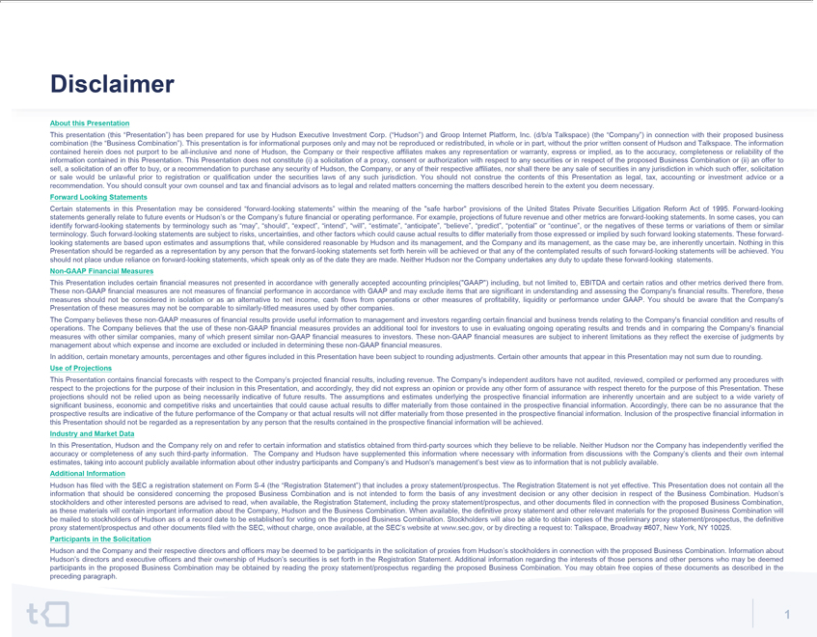



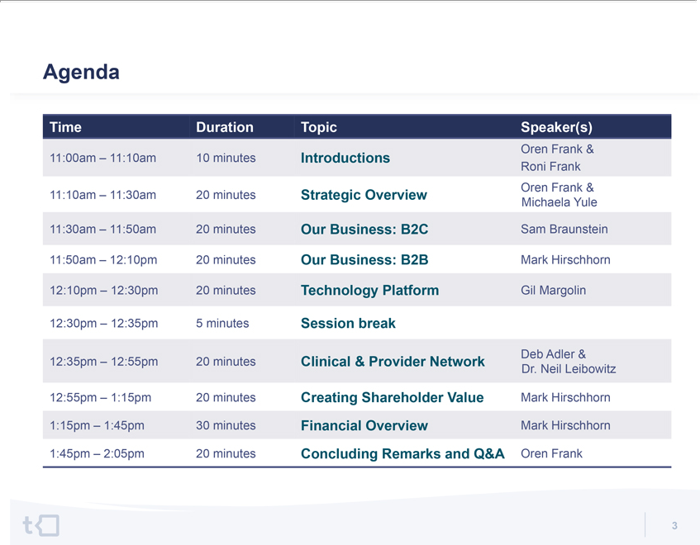







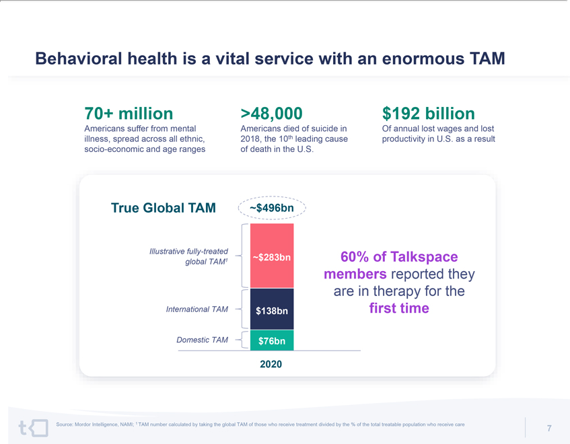

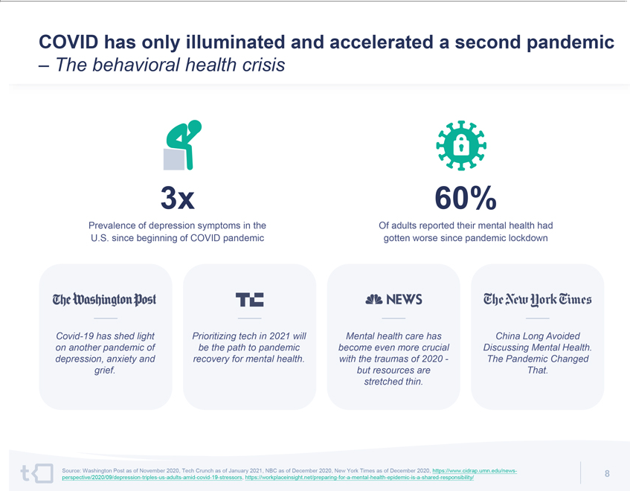

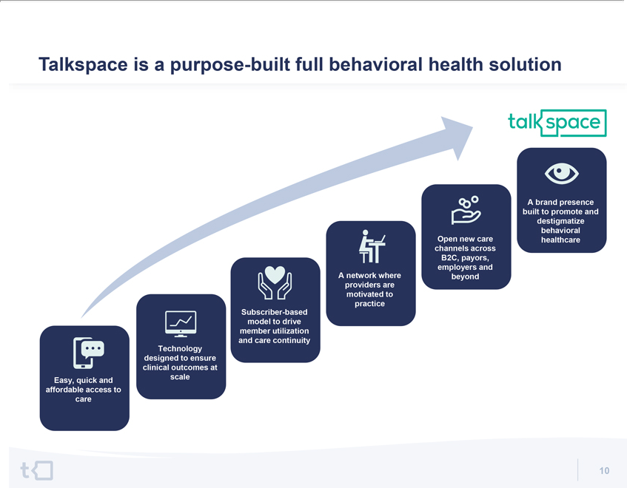

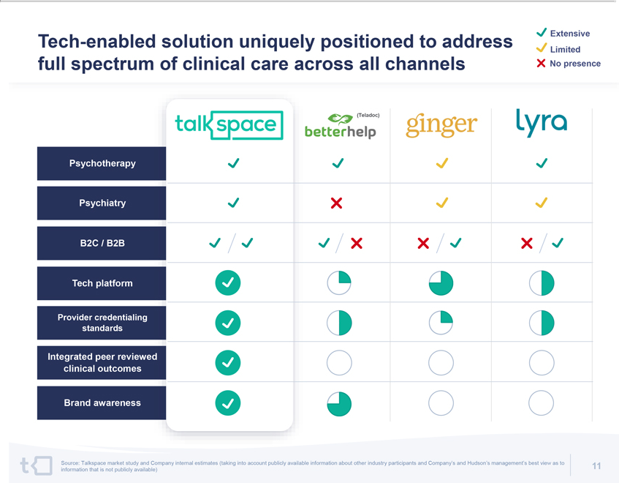

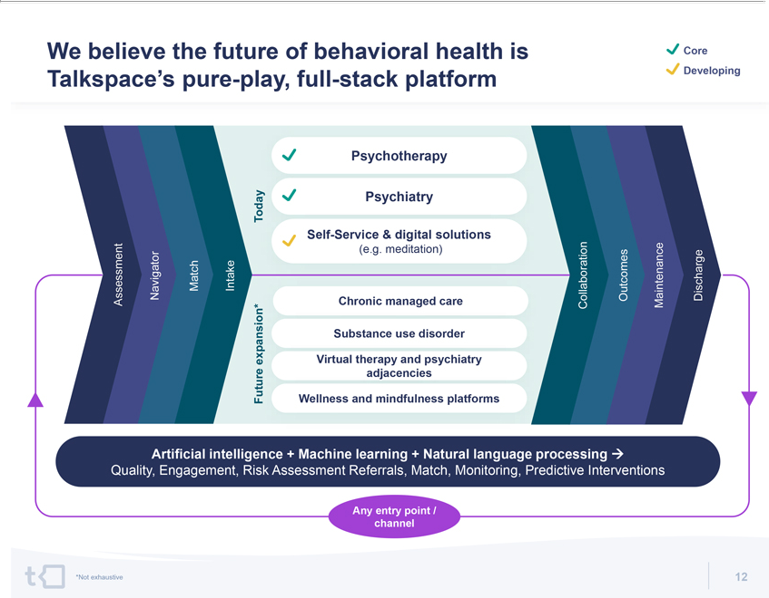





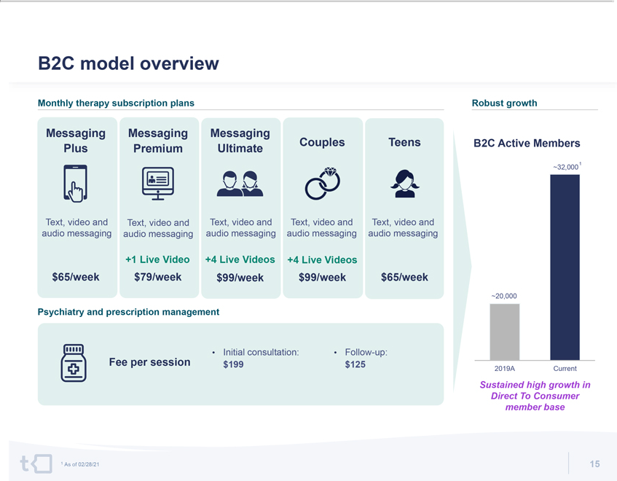

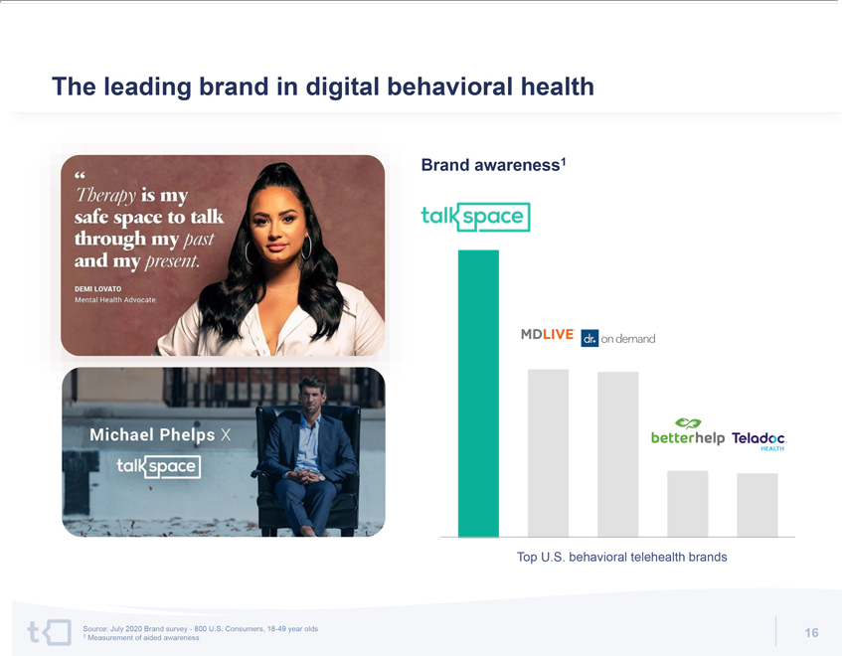

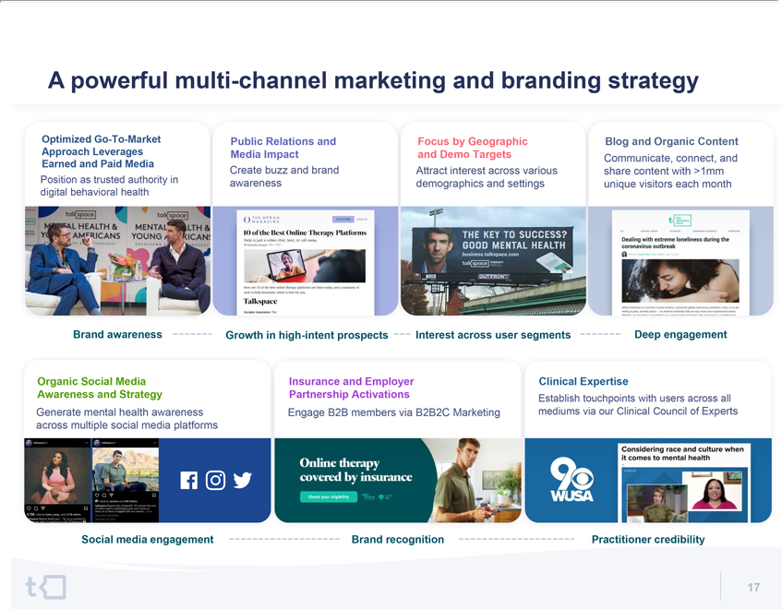

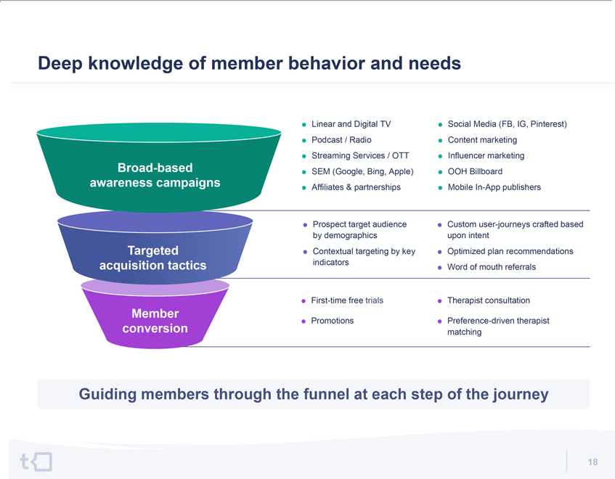

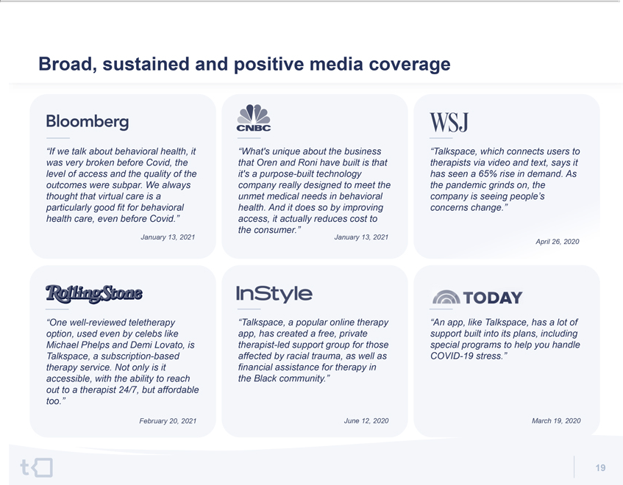





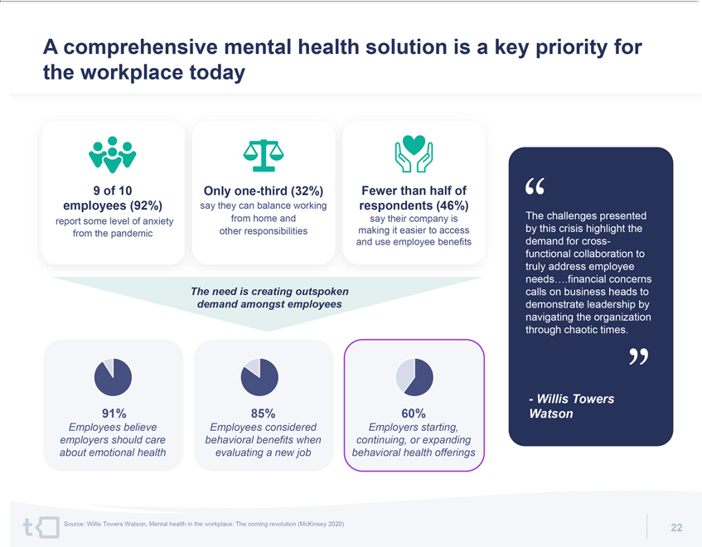

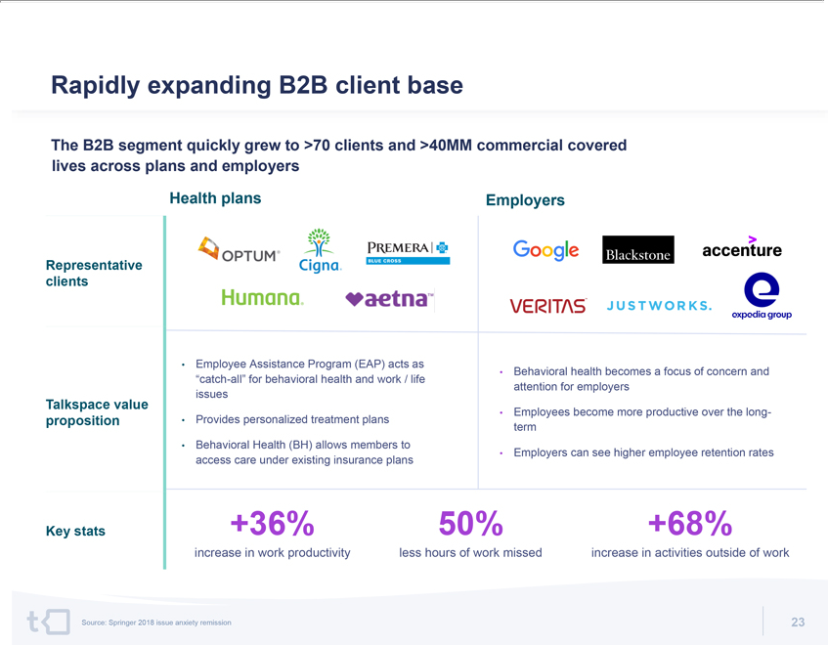

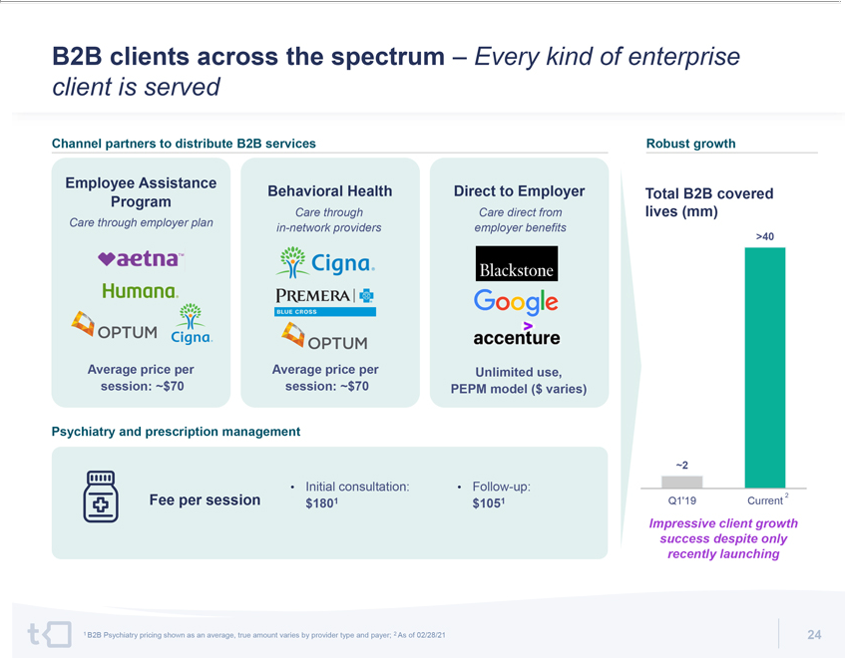

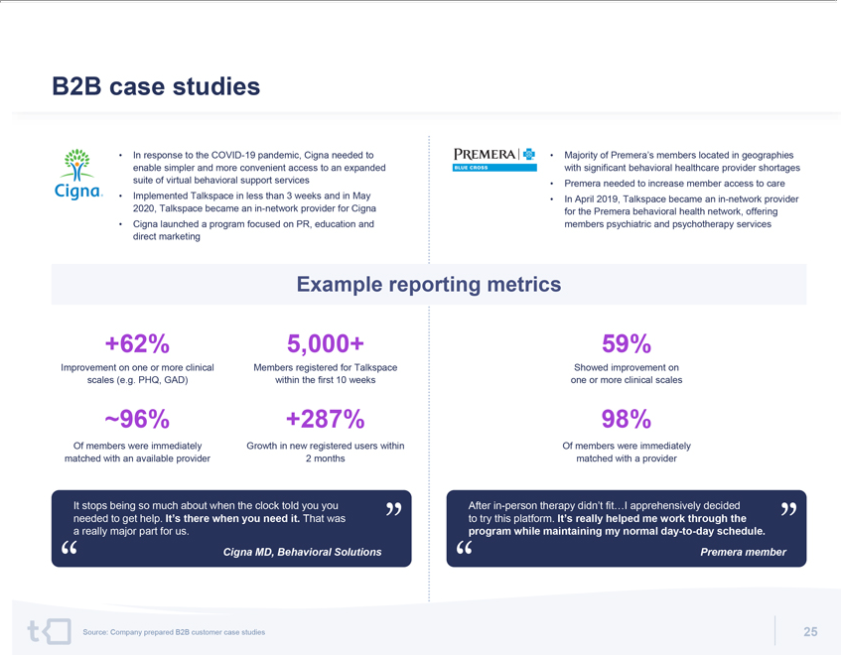







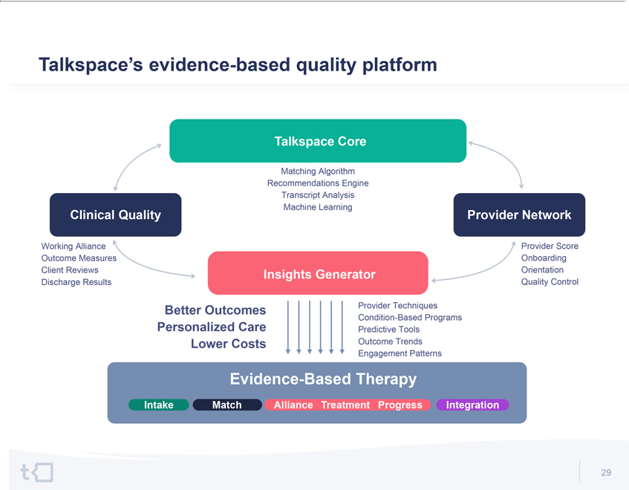

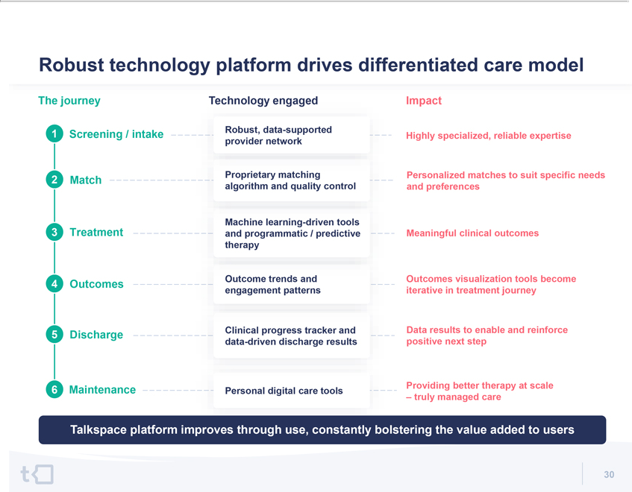





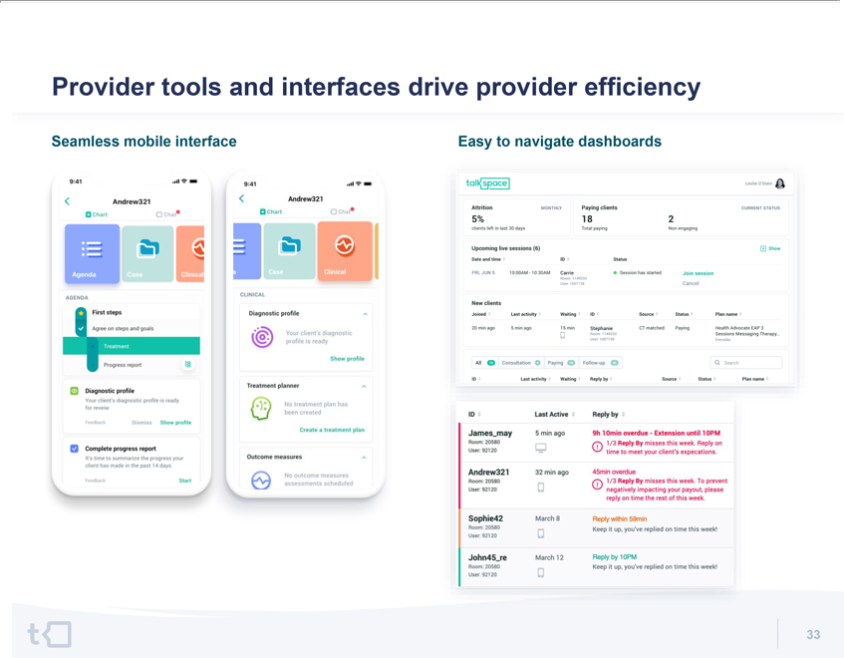



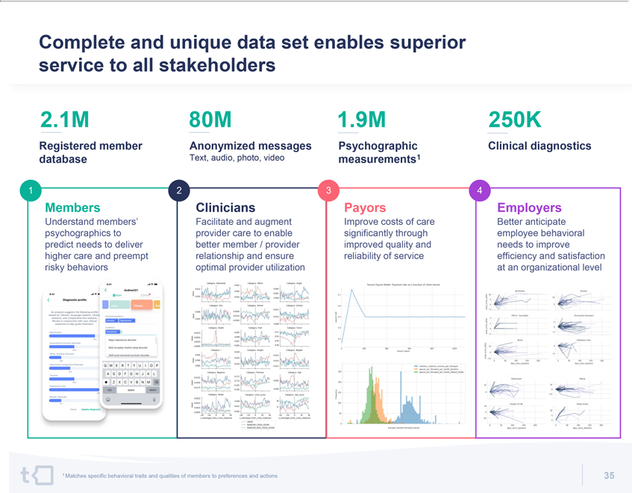

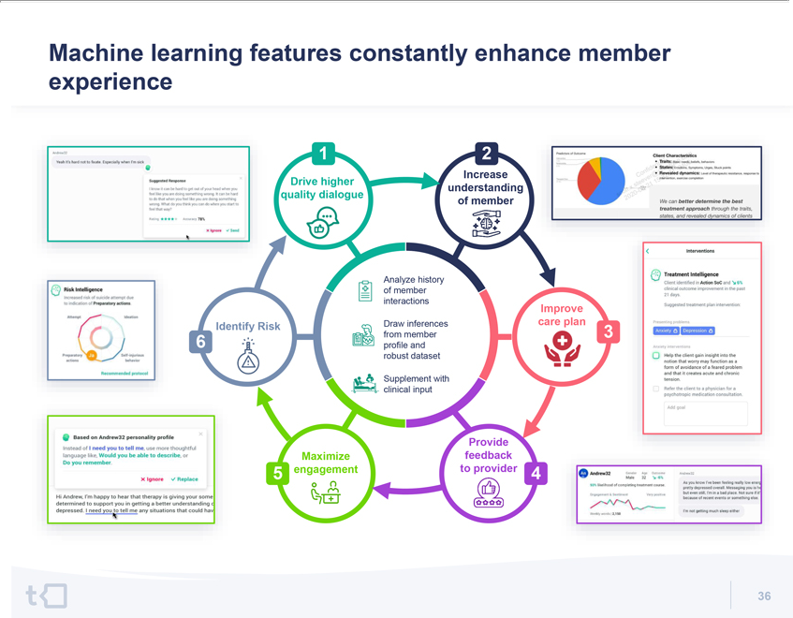

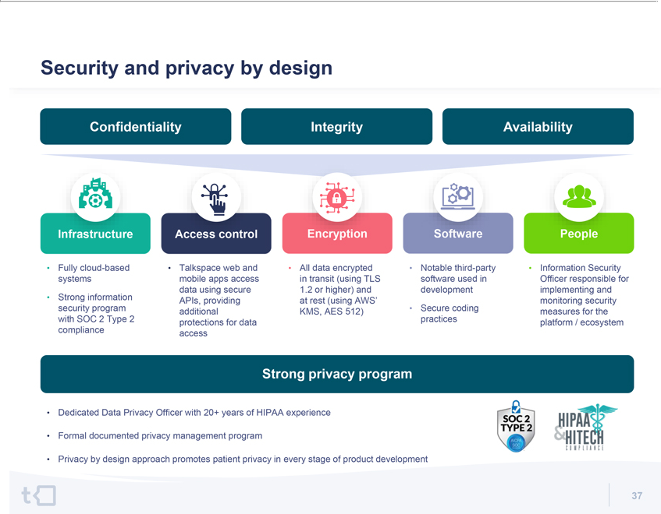

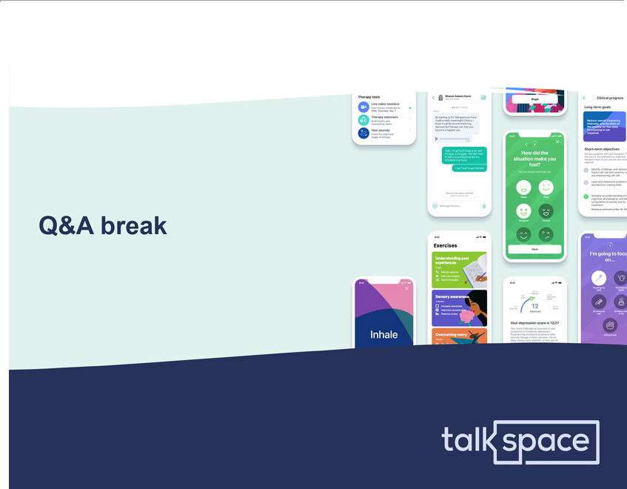

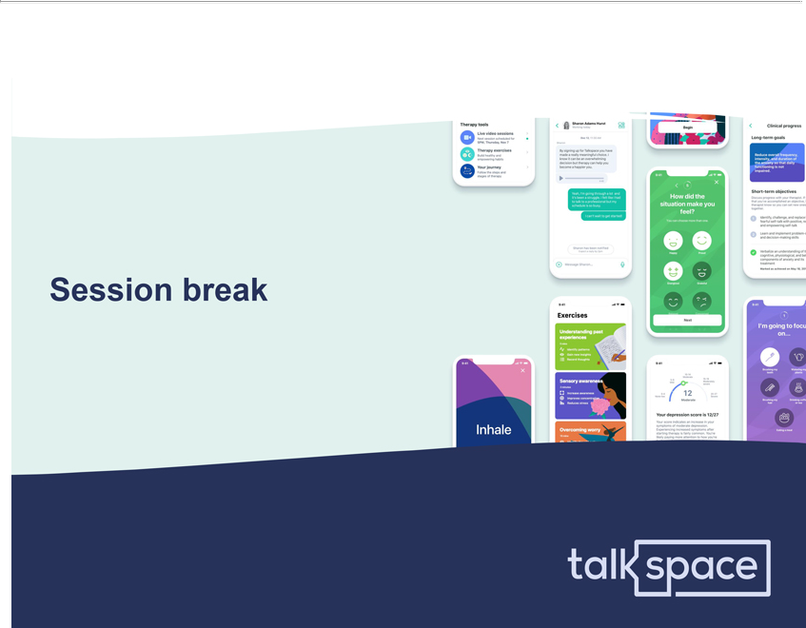





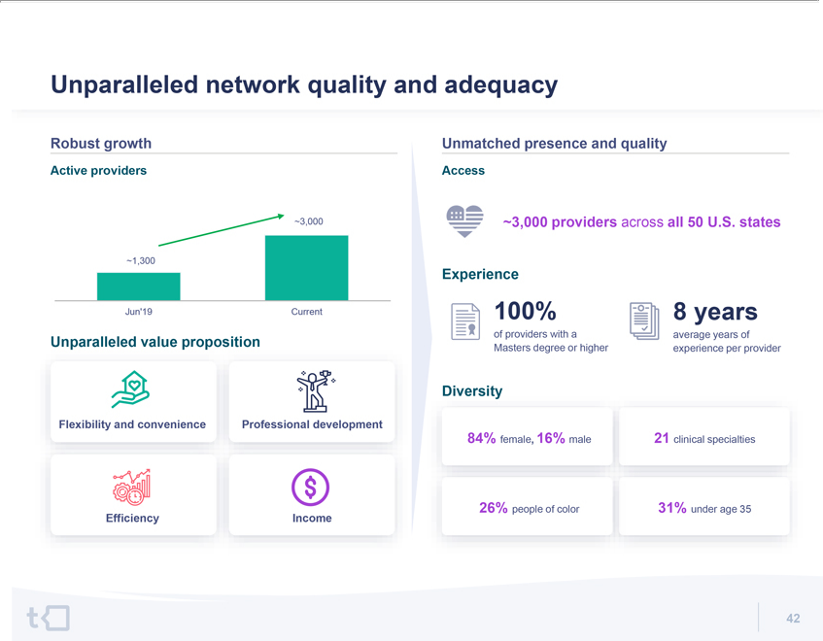

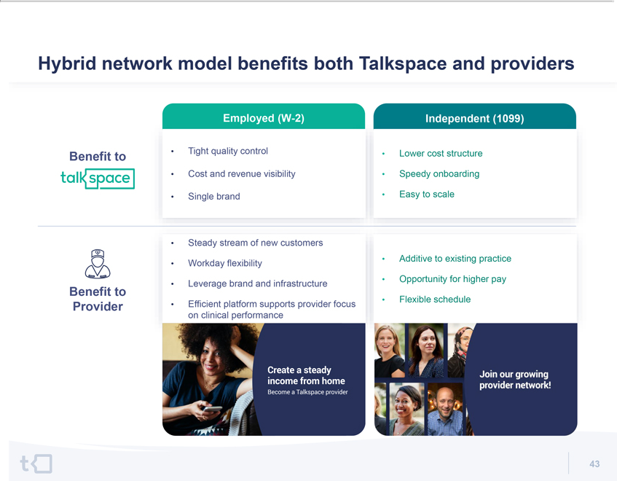

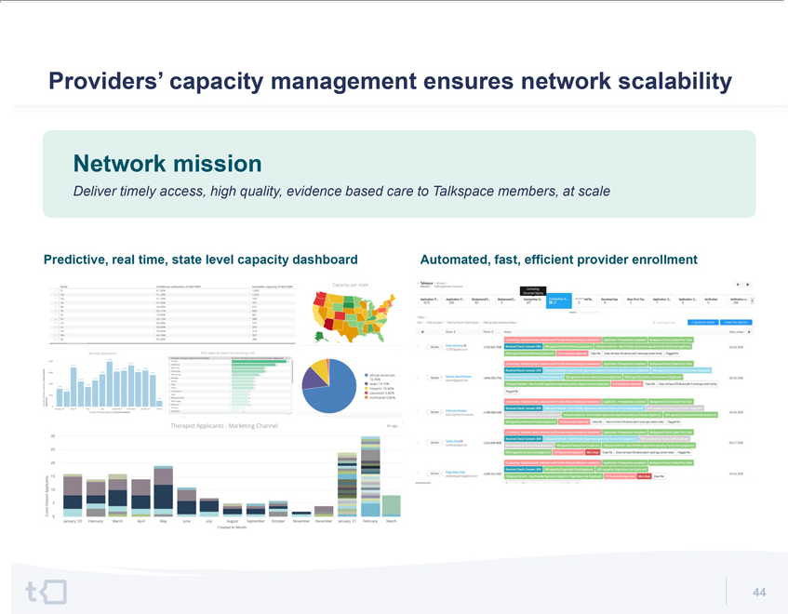

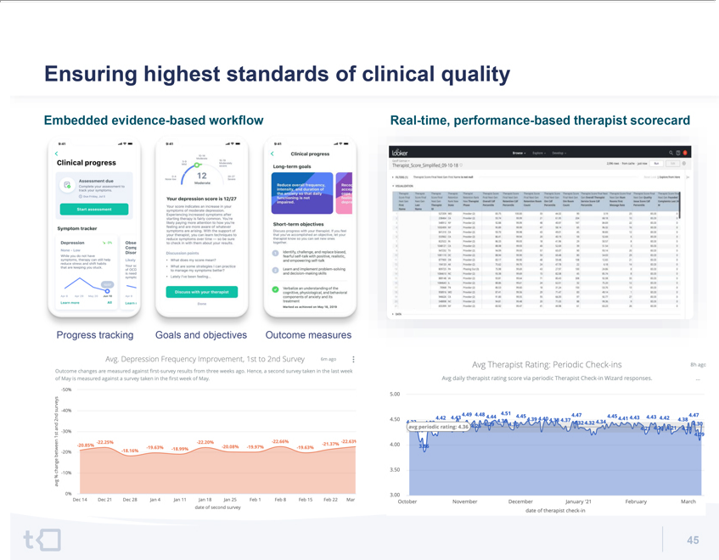

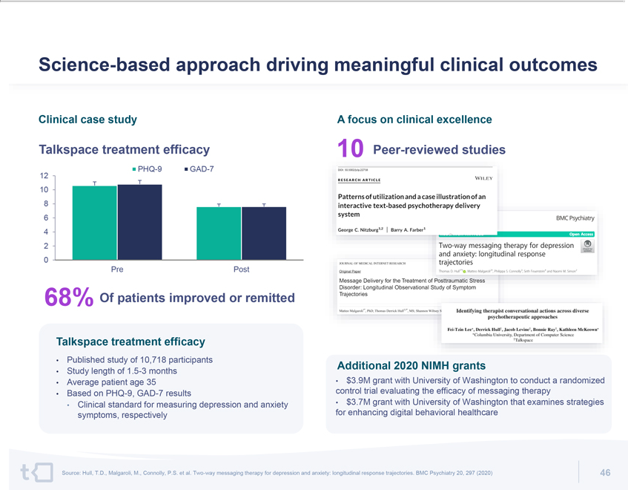





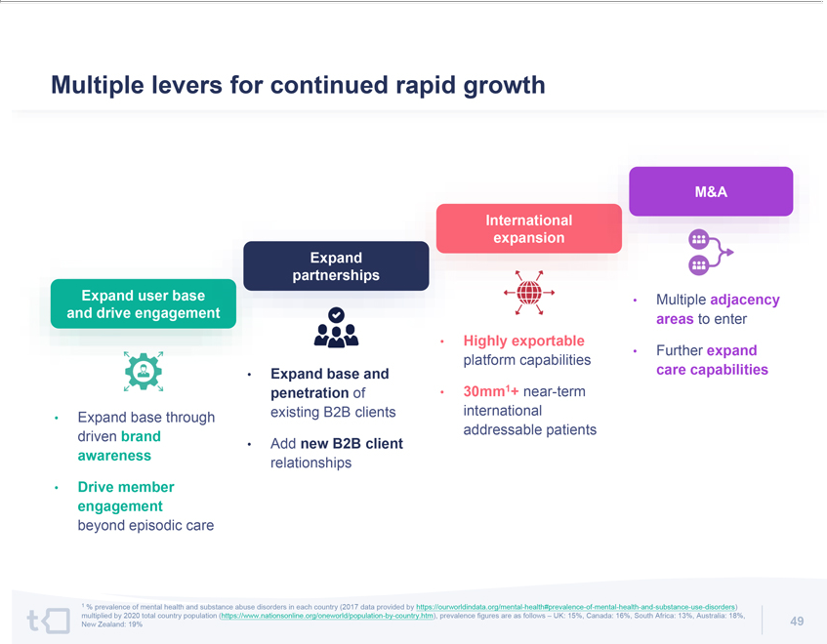

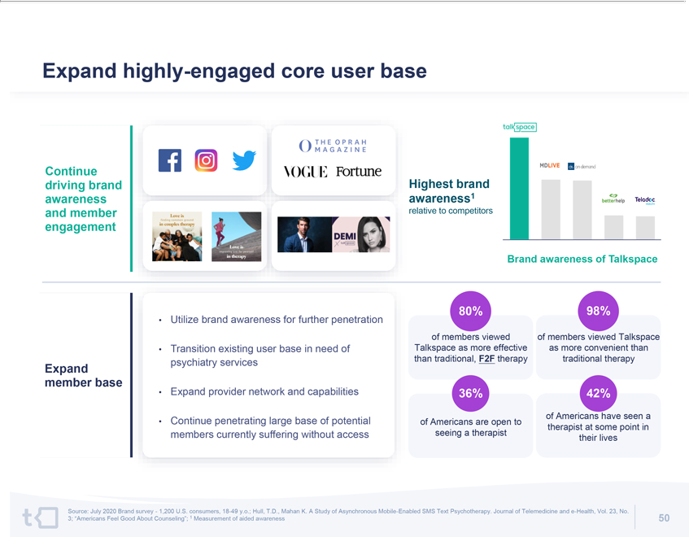

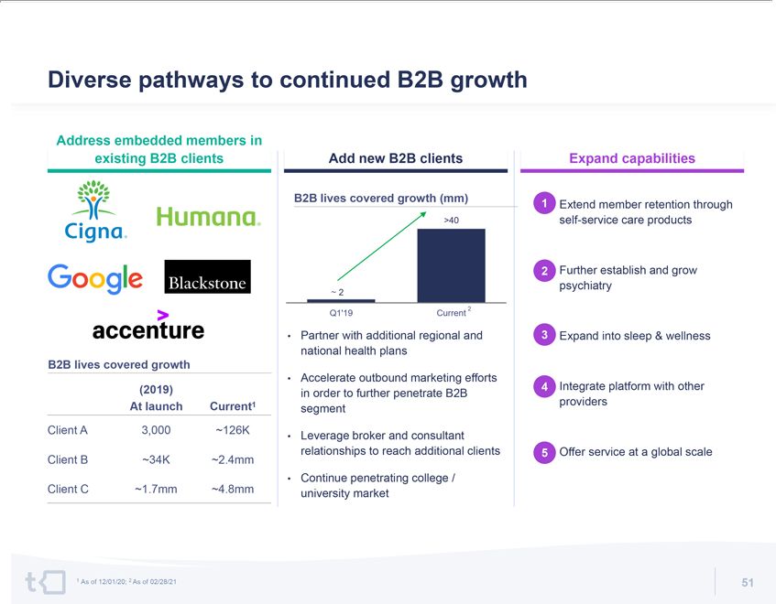

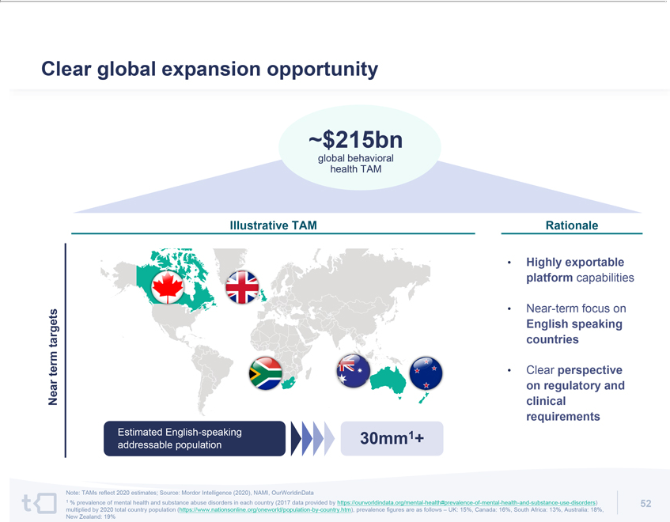

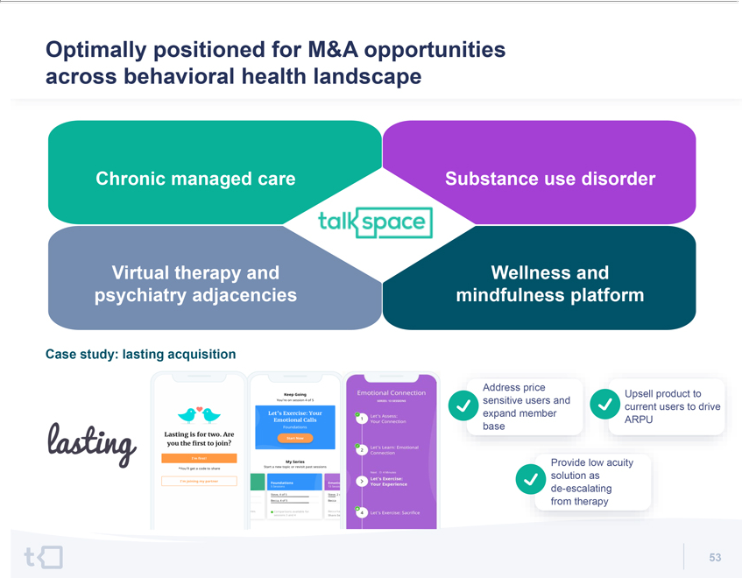



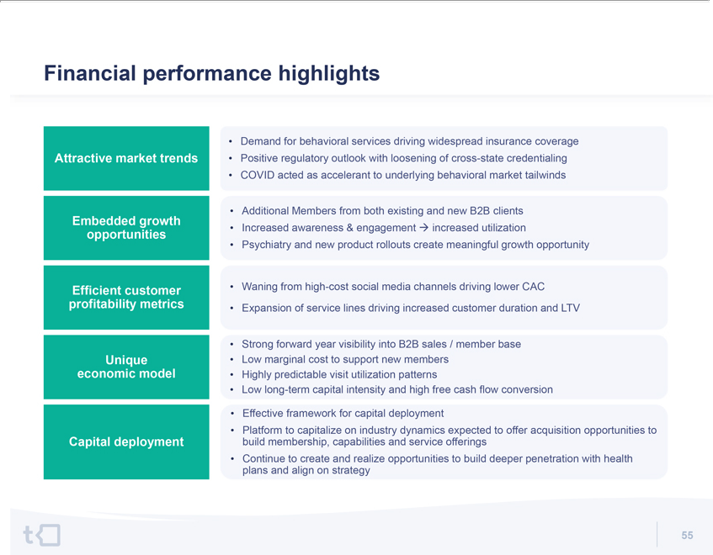

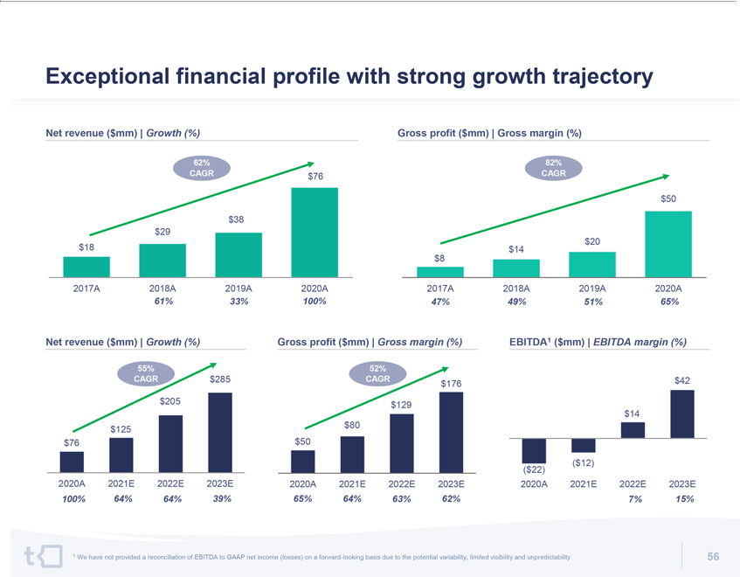

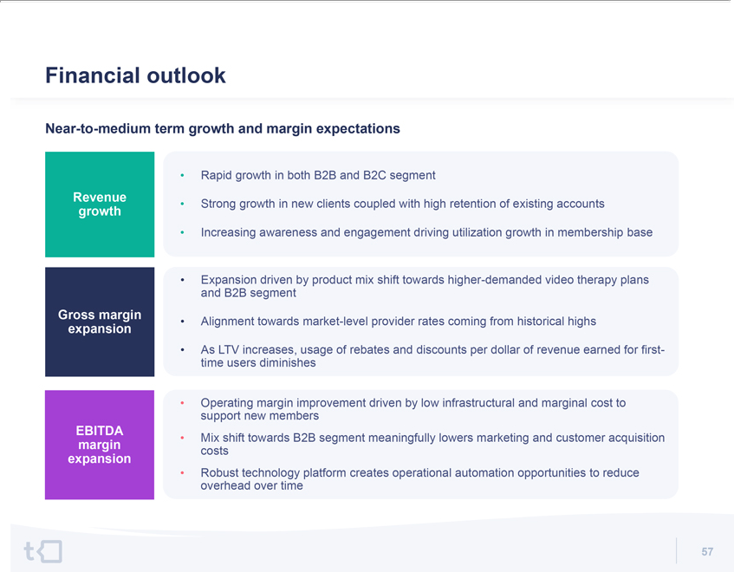

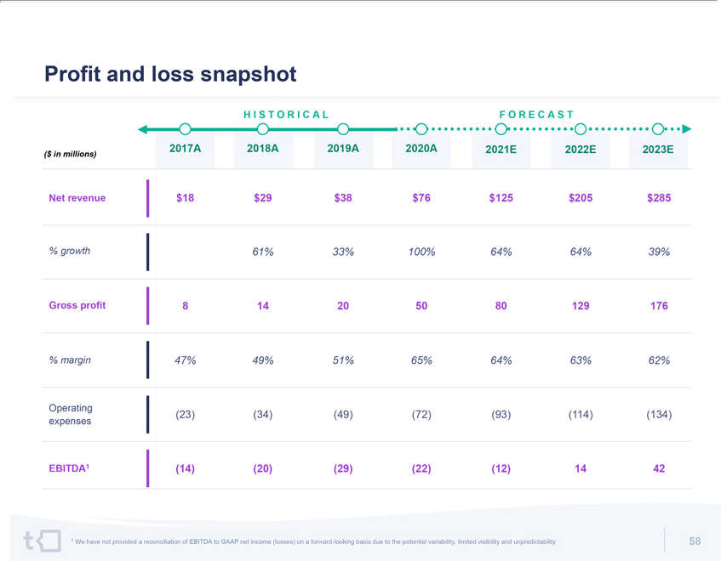

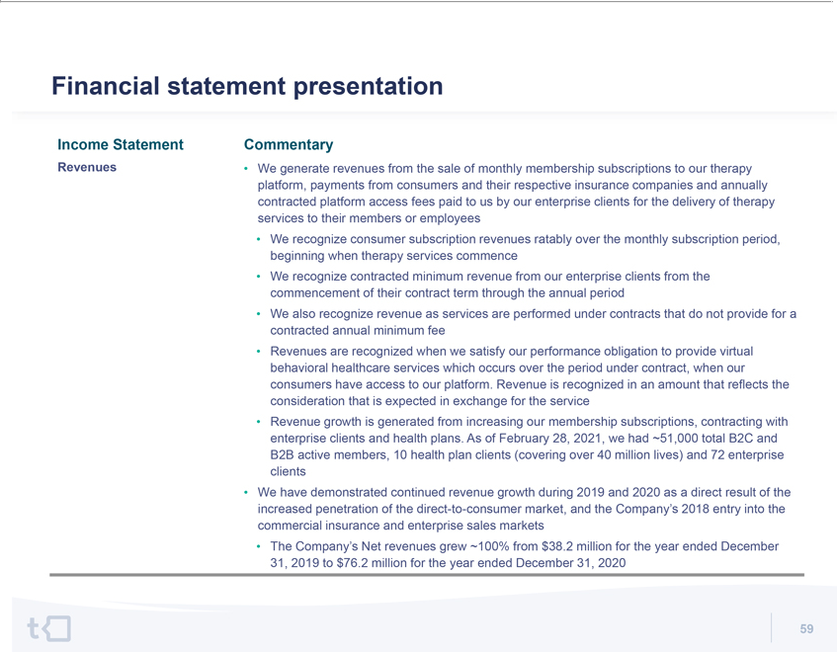

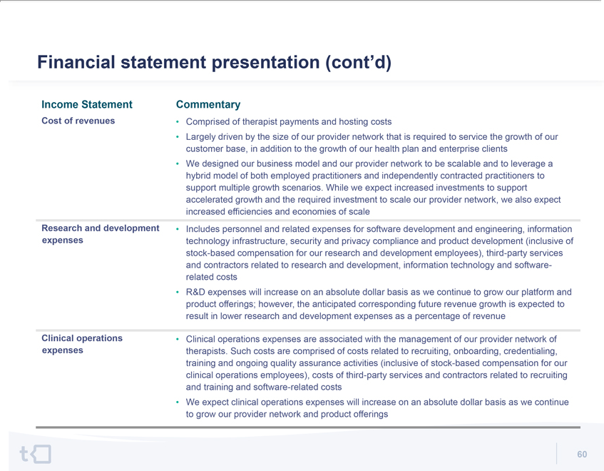

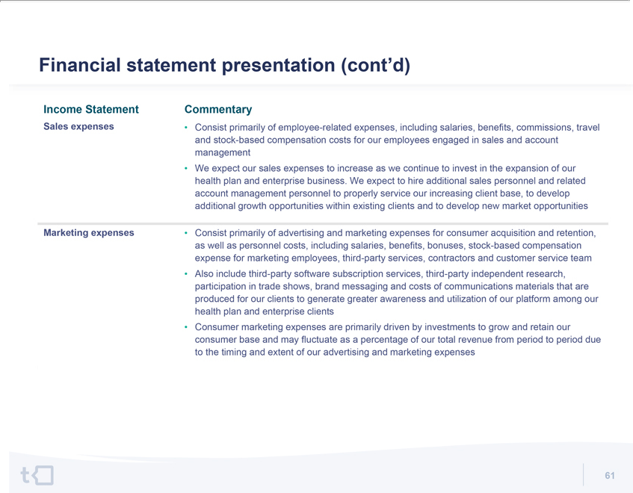

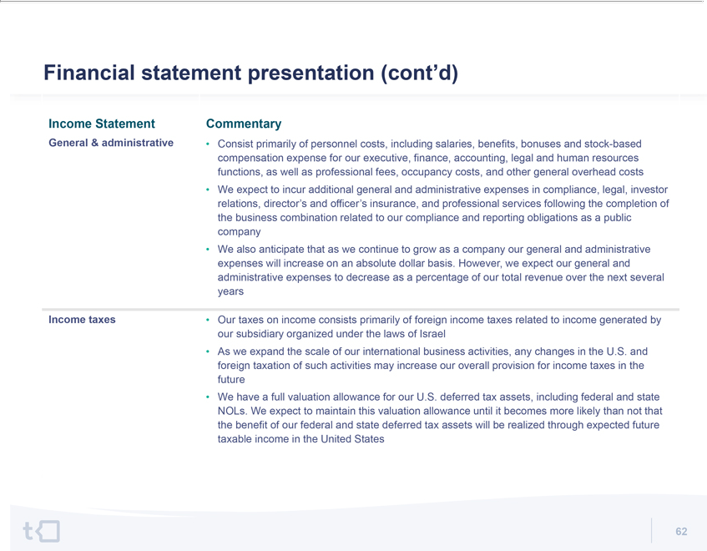

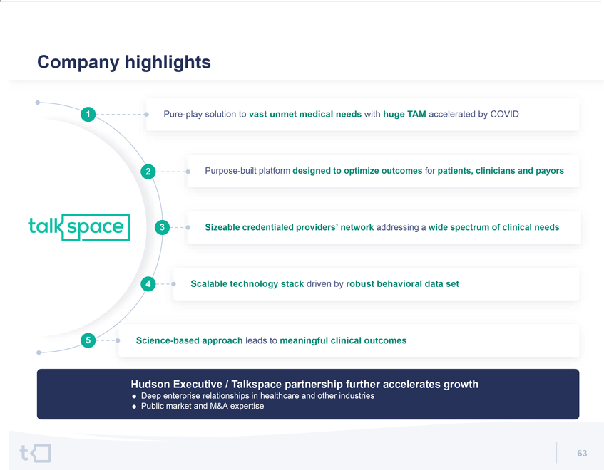







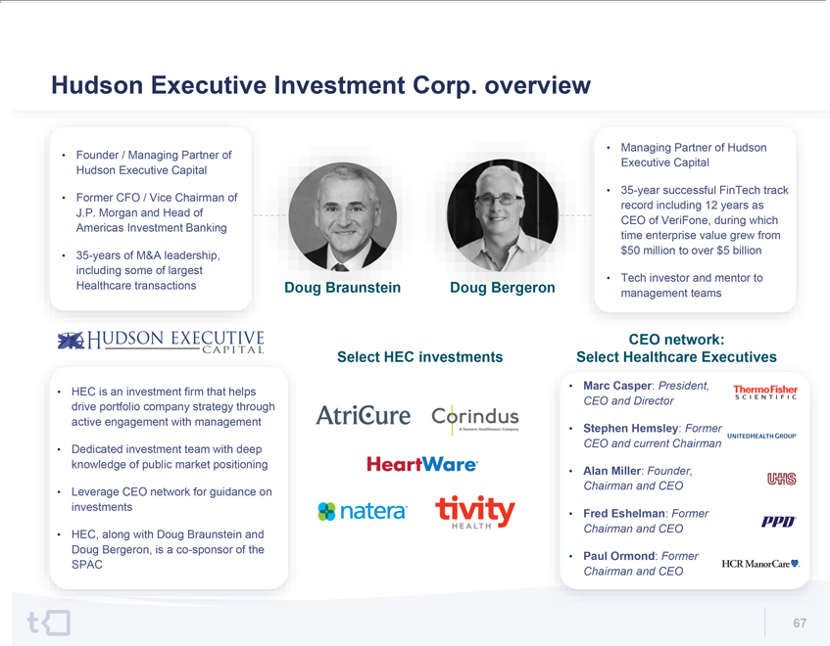

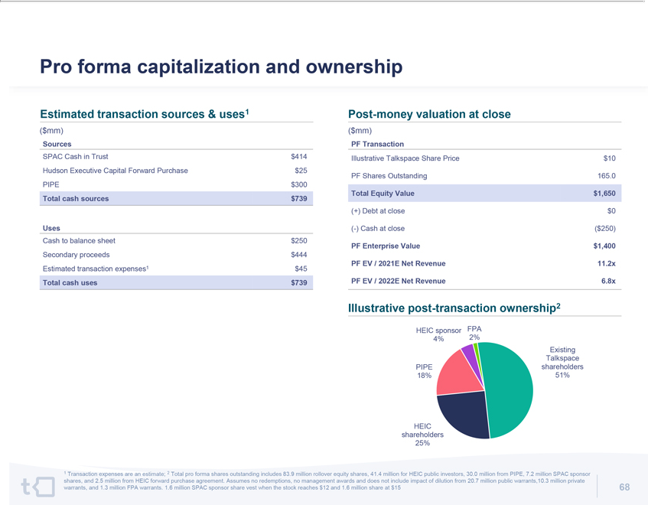

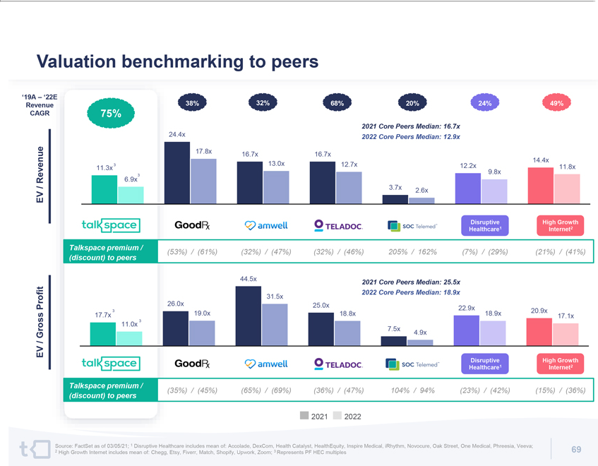



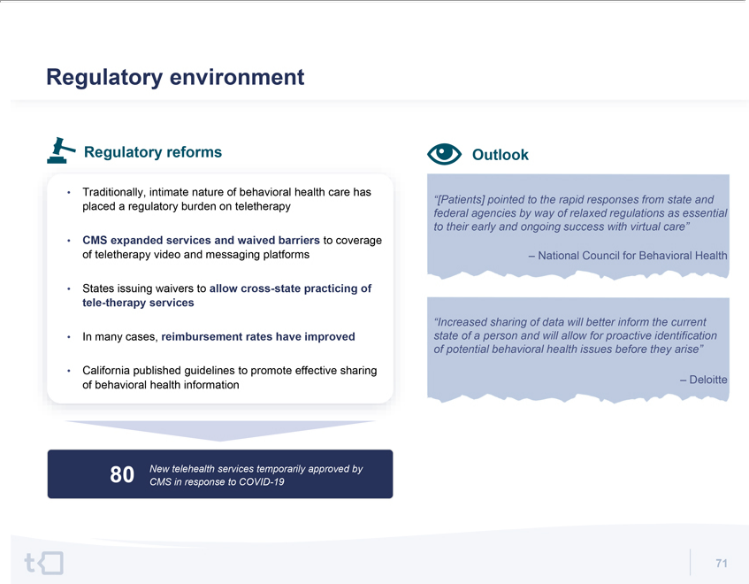

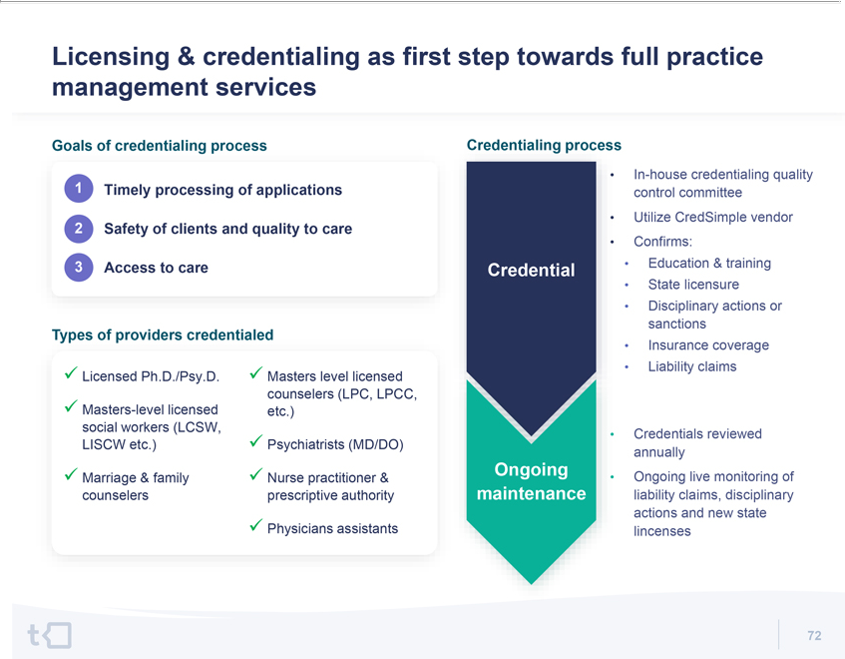



Additional Information and Where to Find It

This press release relates to a proposed transaction between Talkspace and HEIC. This press release does not constitute an offer to sell or exchange, or the solicitation of an offer to buy or exchange, any securities, nor shall there be any sale of securities in any jurisdiction in which such offer, sale or exchange would be unlawful prior to registration or qualification under the securities laws of any such jurisdiction. HEIC has filed a registration statement on Form S-4 with the SEC, which includes a document that serves as a prospectus and proxy statement of HEIC, referred to as a proxy statement/prospectus. A proxy statement/prospectus will be sent to all HEIC shareholders. HEIC also will file other documents regarding the proposed transaction with the SEC. Before making any voting decision, investors and security holders of HEIC are urged to read the registration statement and the related proxy statement/prospectus (including all amendments and supplements thereto) and all other relevant documents filed or that will be filed with the SEC in connection with the proposed transaction as they become available because they will contain important information about the proposed transaction.

Investors and security holders will be able to obtain free copies of the registration statement, the proxy statement/prospectus and all other relevant documents filed or that will be filed with the SEC by HEIC through the website maintained by the SEC at www.sec.gov. The documents filed by HEIC with the SEC also may be obtained free of charge at HEIC’S website at https://hudsoninvestcorp.com/investors or upon written request to Hudson Executive Investment Corp., 570 Lexington Avenue, 35th Floor, New York, NY 10022.

Participants in Solicitation

HEIC and its directors and executive officers may be deemed to be participants in the solicitation of proxies from HEIC’s shareholders in connection with the proposed transaction. A list of the names of such directors and executive officers and information regarding their interests in the business combination is contained in the proxy statement/prospectus. You may obtain free copies of these documents as described in the preceding paragraph.

Forward Looking Statements

This press release contains certain forward-looking statements within the meaning of the federal securities laws with respect to the proposed transaction between Talkspace and HEIC, including statements regarding the anticipated benefits of the transaction, the anticipated timing of the transaction, the services offered by Talkspace and the markets in which it operates, and future financial condition and performance of Talkspace and expected financial impacts of the transaction (including future revenue, pro forma enterprise value and cash balance), the satisfaction of closing conditions to the transaction, the PIPE transaction, and the level of redemptions of HEIC’s public shareholders. These forward-looking statements generally are identified by the words “believe,” “project,” “expect,” “anticipate,” “estimate,” “intend,” “strategy,” “future,” “opportunity,” “plan,” “may,” “should,” “will,” “would,” “will be,” “will continue,” “will likely result,” and similar expressions. Forward-looking statements are predictions, projections and other statements about future events that are based on current expectations and assumptions and, as a result, are subject to risks and uncertainties. Many factors could cause actual future events to differ materially from the forward looking statements in this press release, including but not limited to: (i) the risk that the transaction may not be completed in a timely manner or at all, which may adversely affect the price of HEIC’s securities, (ii) the risk that the transaction may not be completed by HEIC’s business combination deadline and the potential failure to obtain an extension of the business combination deadline if sought by HEIC, (iii) the failure to satisfy the conditions to the consummation of the transaction, including the approval of the merger agreement by the shareholders of HEIC, the satisfaction of the minimum trust account amount following redemptions by HEIC’s public shareholders and the receipt of certain governmental and regulatory approvals, (iv) the lack of a third party valuation in determining whether or not to pursue the business combination, (v) the occurrence of any event, change, or other circumstance that could give rise to the termination of the merger agreement, (vi) the effect of the announcement or pendency of the transaction on Talkspace’s business relationships, performance, and business generally, (vii) risks that the proposed transaction disrupts current plans and operations of Talkspace, (viii) the outcome of any legal proceedings that may be instituted against Talkspace or against HEIC related to the merger agreement or the proposed transaction, (ix) the ability to maintain the listing of HEIC’s securities on The Nasdaq Stock Market, (x) the price of HEIC’s securities may be volatile due to a variety of factors, including changes in the competitive and highly regulated industries in which HEIC plans to operate, variations in performance across competitors, changes in laws and regulations affecting HEIC’s business and changes in the combined capital structure, (xi) the ability to implement business plans, forecasts, and other expectations after the completion of the proposed business combination, and identify and realize additional opportunities, and (xii) the risk of downturns in the highly competitive telehealth and teletherapy markets. The foregoing list of factors is not exhaustive. You should carefully consider the foregoing factors and the other risks and uncertainties described in the “Risk Factors” section of HEIC’s Registration Statement on Form S-4 discussed above and other documents filed by HEIC from time to time with the SEC. These filings identify and address other important risks and uncertainties that could cause actual events and results to differ materially from those contained in the forward-looking statements. Forward-looking statements speak only as of the date they are made. Readers are cautioned not to put undue reliance on forward-looking statements, and Talkspace and HEIC assume no obligation and do not intend to update or revise these forward-looking statements, whether as a result of new information, future events, or otherwise. Neither Talkspace nor HEIC gives any assurance that either Talkspace or HEIC will achieve its expectations.

